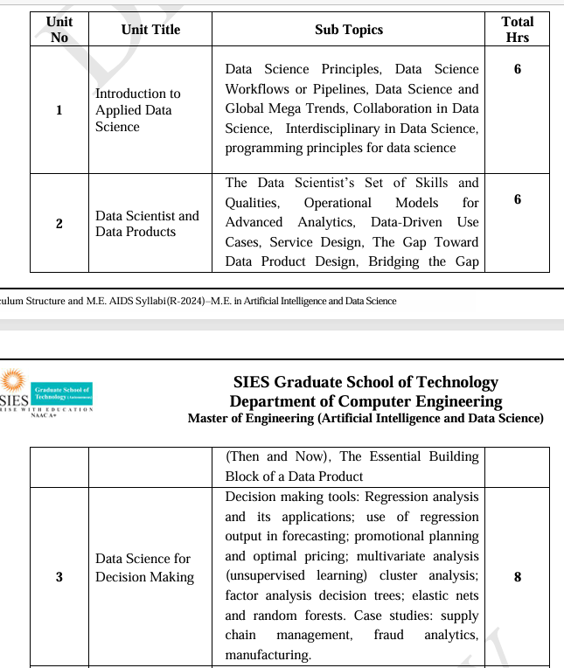

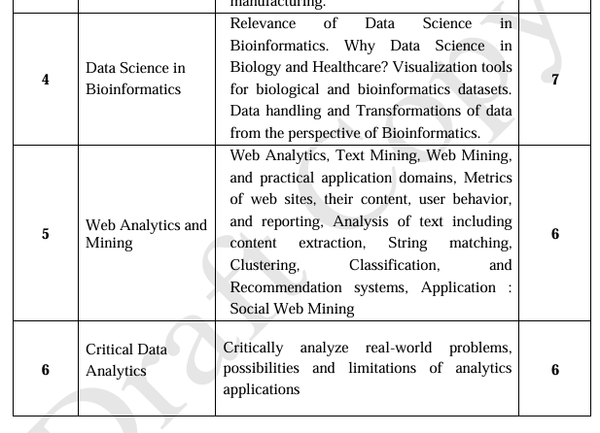
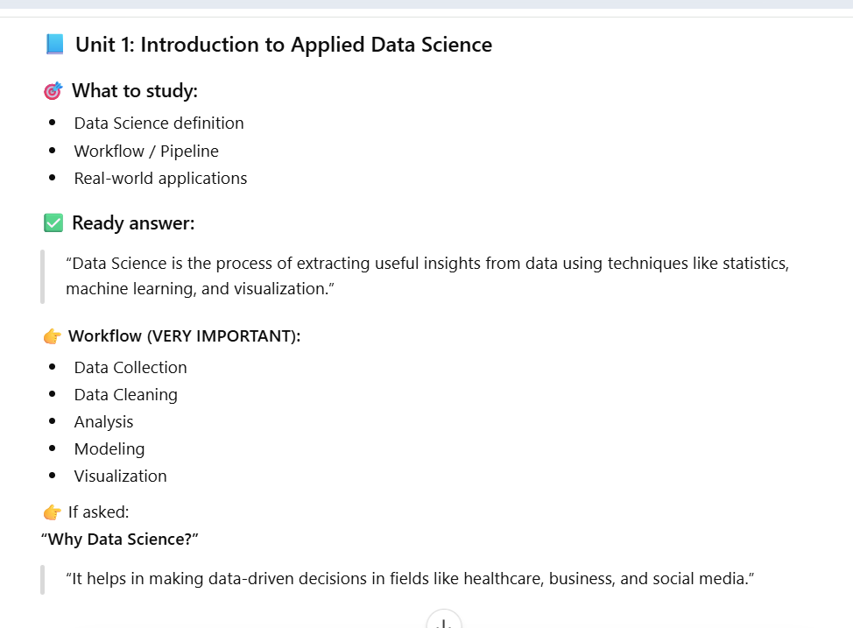
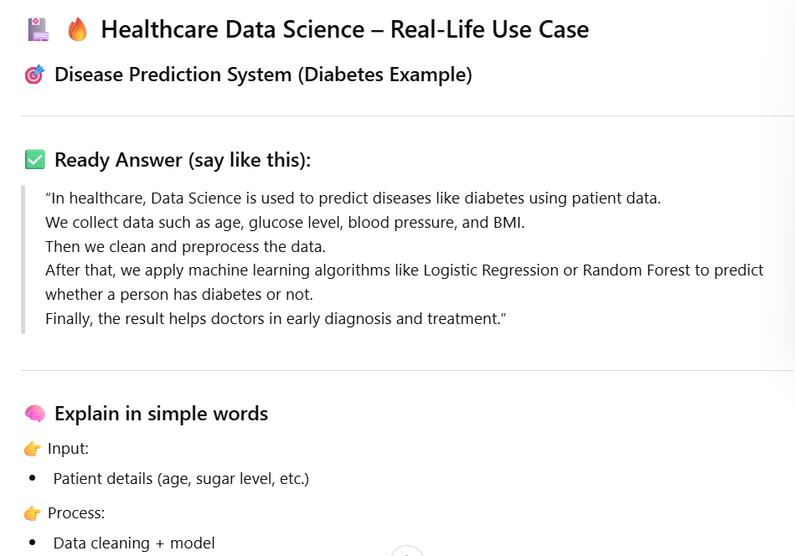

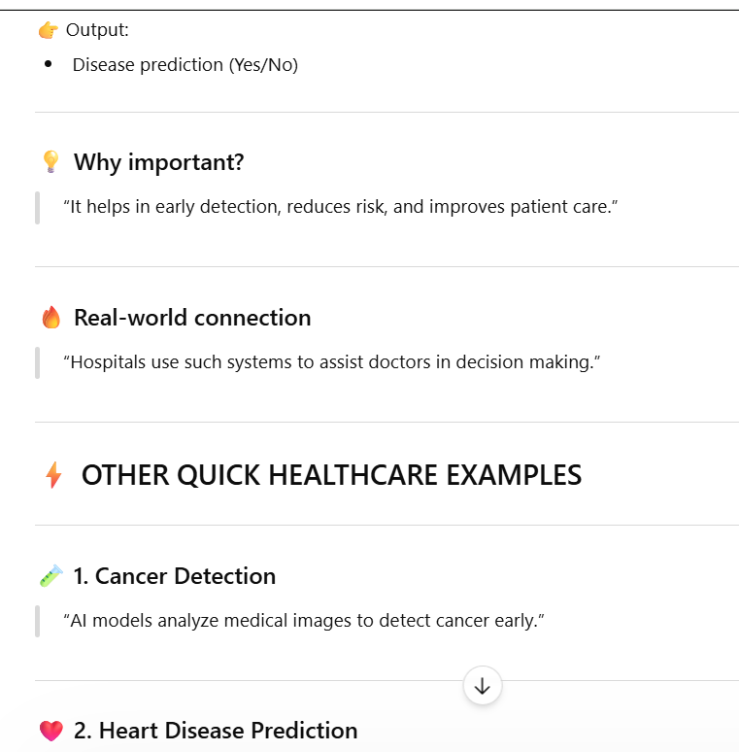
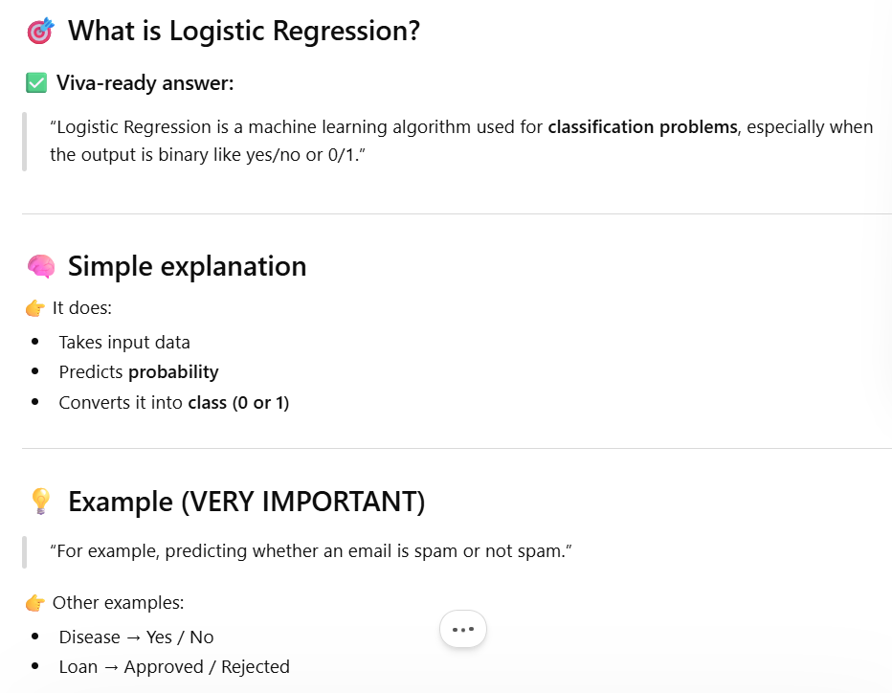
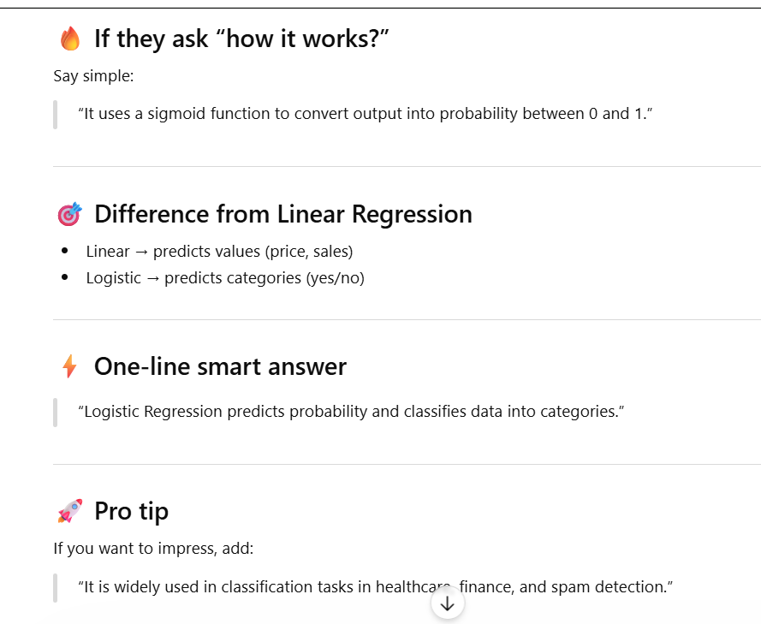
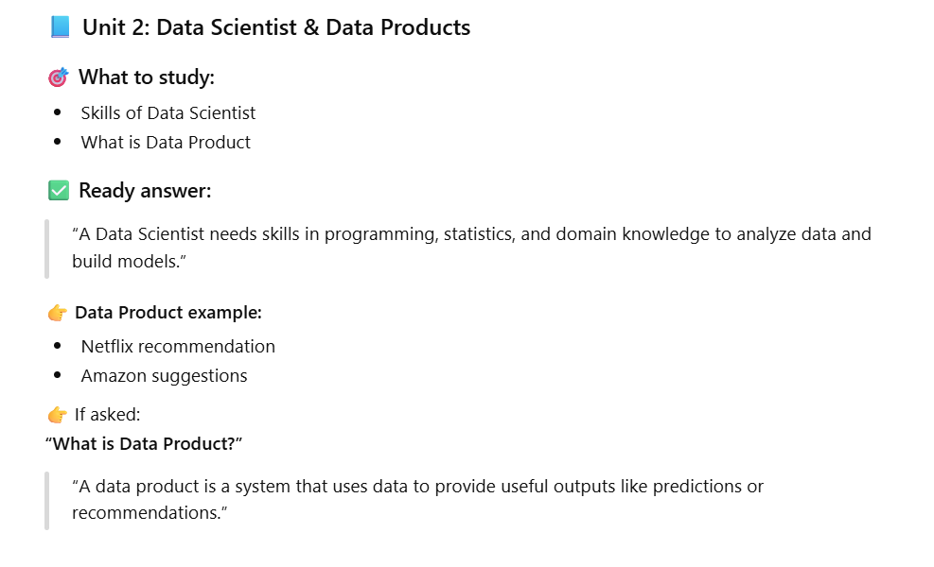
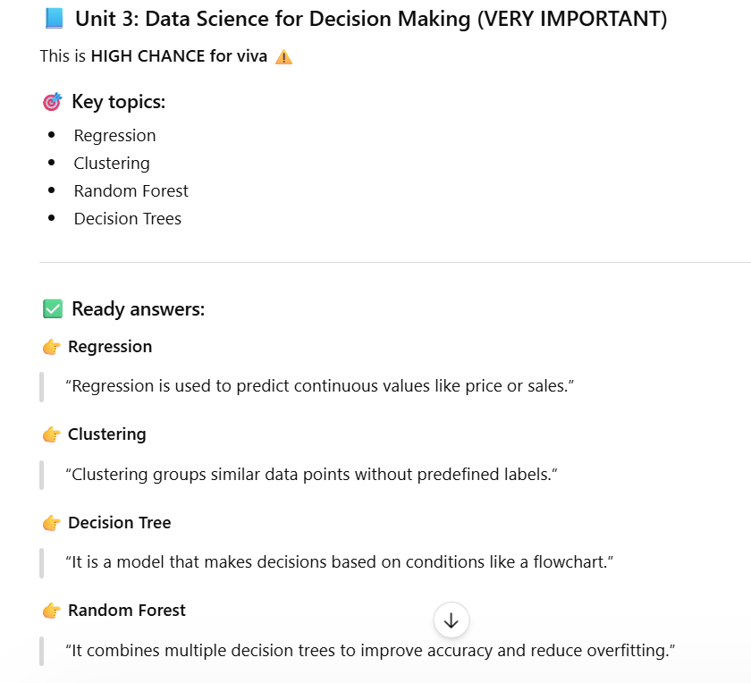

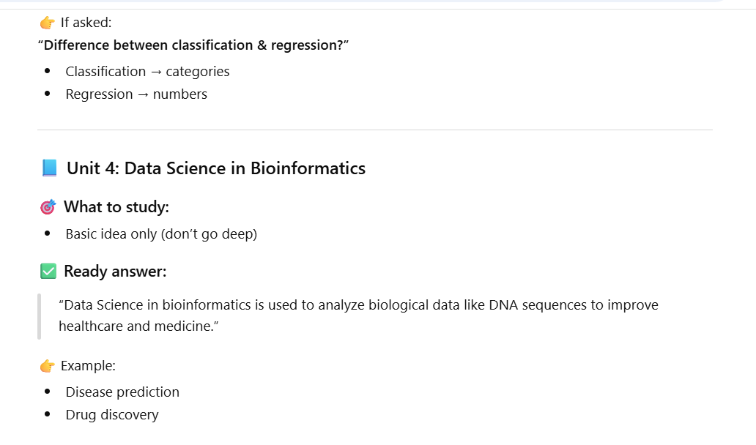

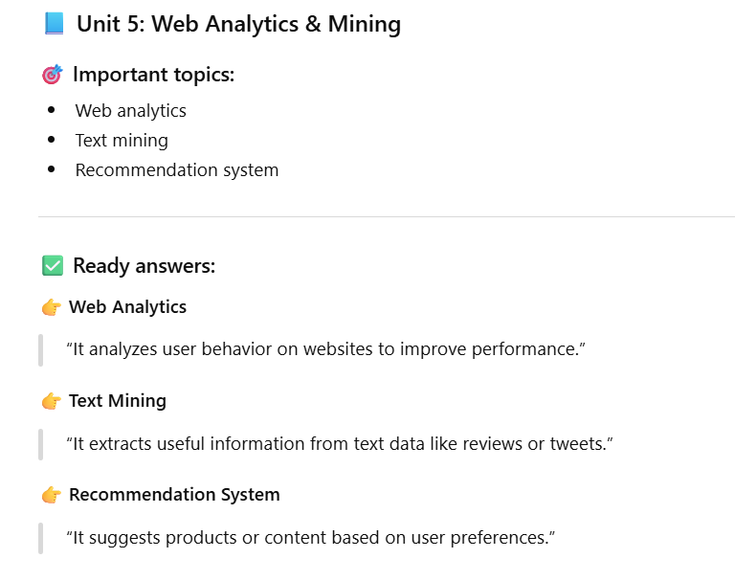

Web Analytics is the collection, measurement, analysis, and reporting of website data to understand how users find, use, and interact with a website, and to improve business outcomes.
In simple terms
Web analytics helps answer questions like:
Who is visiting the website?
Where are they coming from?
What are they doing on the site?
Are they completing goals (sign-ups, purchases, downloads)?
Key components
Traffic metrics: users, sessions, pageviews
Behavior metrics: bounce rate, time on page, pages per session
Acquisition: organic search, paid ads, social, referrals
Conversion: form submissions, purchases, clicks
Audience: location, device, browser
Text Mining is the process of extracting useful information, patterns, and insights from large amounts of unstructured text data using data science, NLP, and machine learning techniques

What text mining does
Identifies keywords and topics
Detects patterns and trends
Classifies text into categories
Extracts entities (names, places, dates)
Analyzes sentiment (positive/negative/neutral)
Common techniques
Tokenization – splitting text into words
Stop-word removal – removing common words (is, the, and)
Stemming / Lemmatization – reducing words to root form
TF-IDF – measuring word importance
Topic Modeling – discovering themes (LDA)
Sentiment Analysis
Critical data analytics
Data Analytics is the process of collecting, cleaning, analyzing, and interpreting data to discover patterns, generate insights, and support better decision-making.
In simple terms
Data analytics helps organizations answer questions, solve problems, and make decisions based on data instead of guesswork.
What data analytics involves
Collecting data from sources like databases, apps, websites, or sensors
Cleaning and transforming data to ensure accuracy
Analyzing data to identify trends and patterns
Visualizing results using charts, dashboards, or reports
Drawing conclusions to guide actions and strateg
Types of data analytics
- Descriptive analytics – What happened?
- Diagnostic analytics – Why did it happen?
- Predictive analytics – What is likely to happen next?
- Prescriptive analytics – What should we do?
Centrality is a concept from data science, graph theory, and network analysis that measures how important or influential a node is within a network

A node could represent a person, webpage, city, computer, or organization, and links represent relationships or connections between them.
Common types of centrality
1. Degree Centrality
- Measures number of direct connections
- High degree = highly connected node
Example: A person with many contacts
Betweenness Centrality
- Measures how often a node lies on shortest paths between other nodes
- Identifies bridges or gatekeepers
Example: Someone connecting two teams
Closeness Centrality
- Measures how quickly a node can reach all others
- High closeness = fast information spread
Eigenvector Centrality
- Measures influence based on connections to important nodes
- Being connected to strong nodes increases importance
Example: Linked to popular or powerful nodes

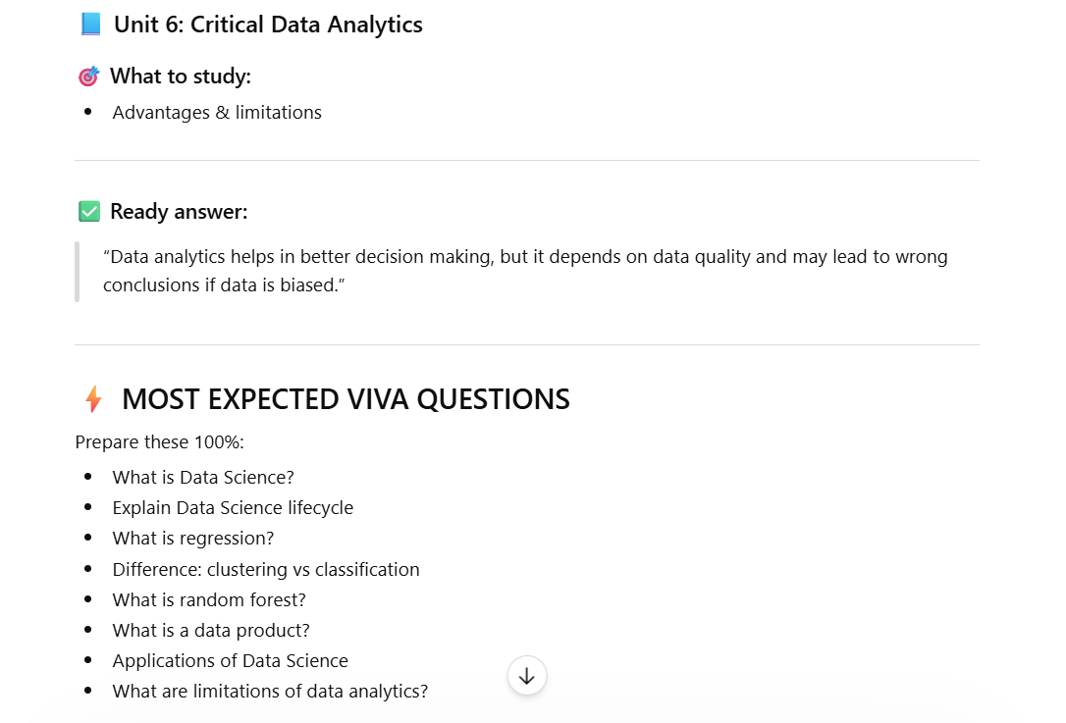
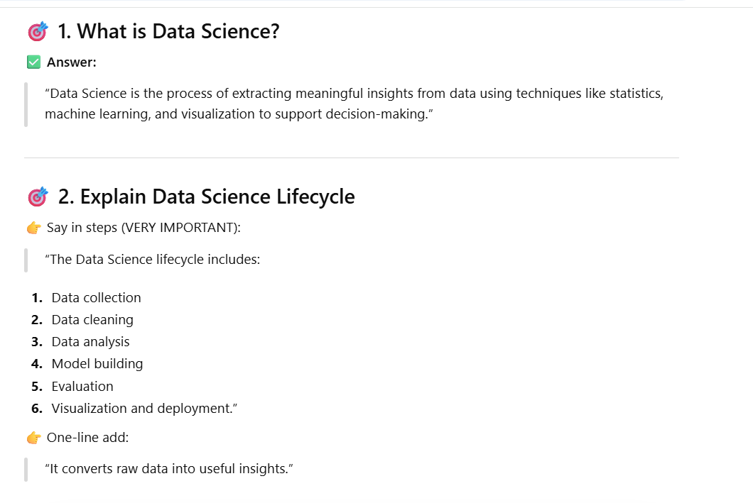
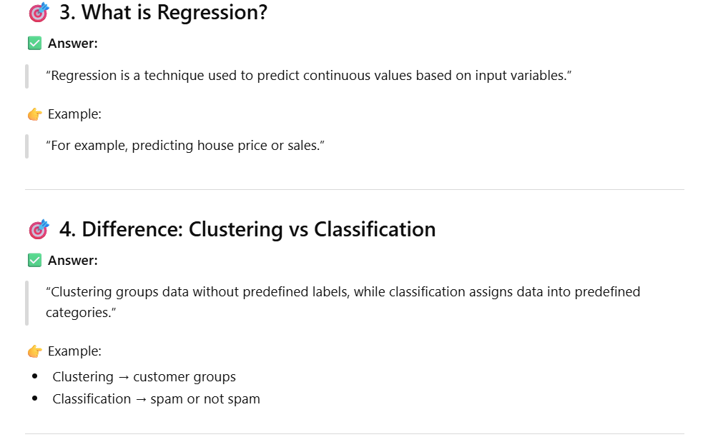
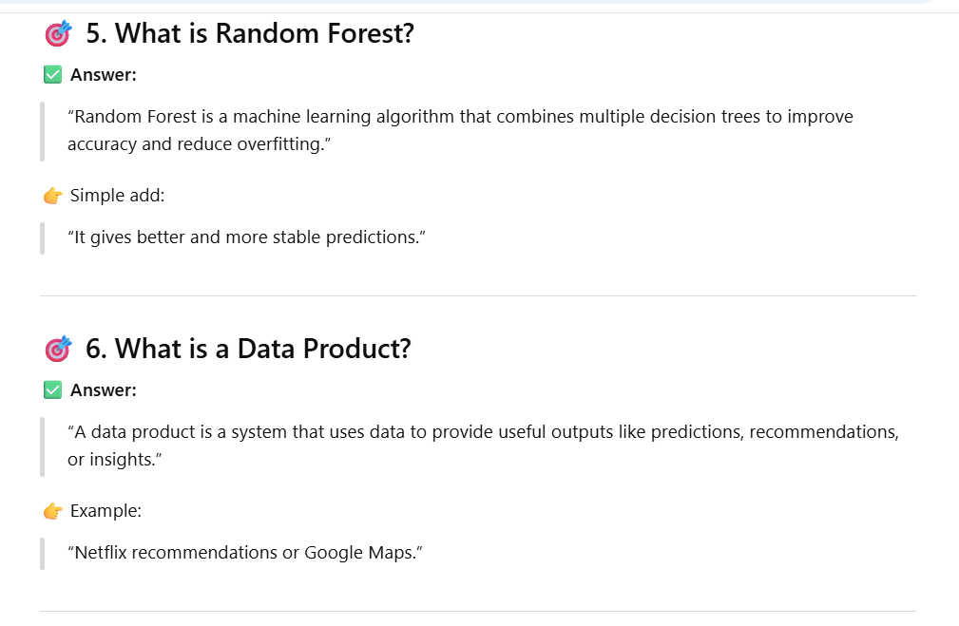
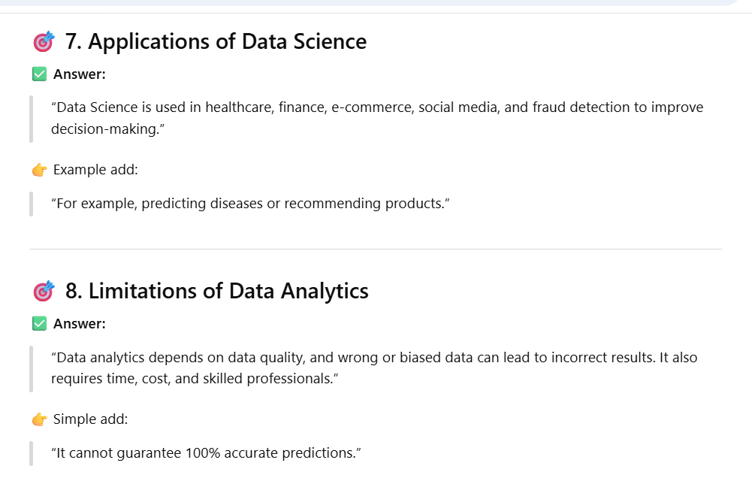
SNA syllabus
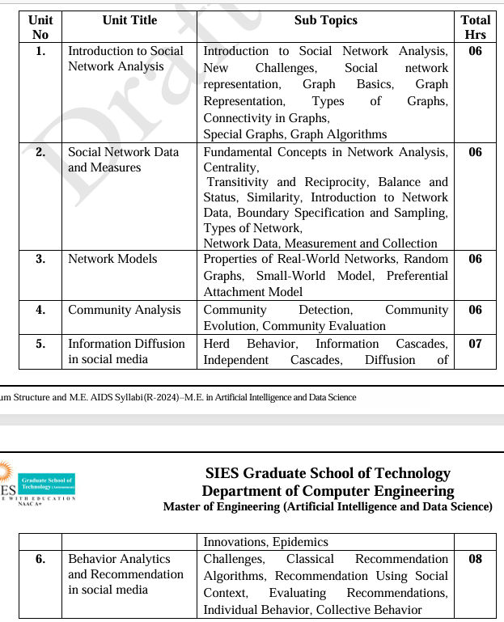
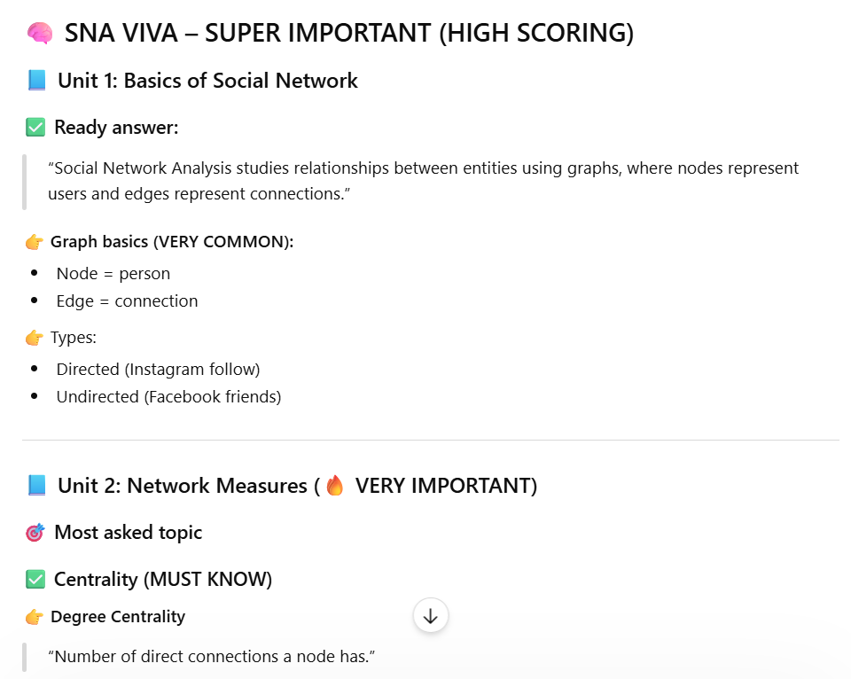

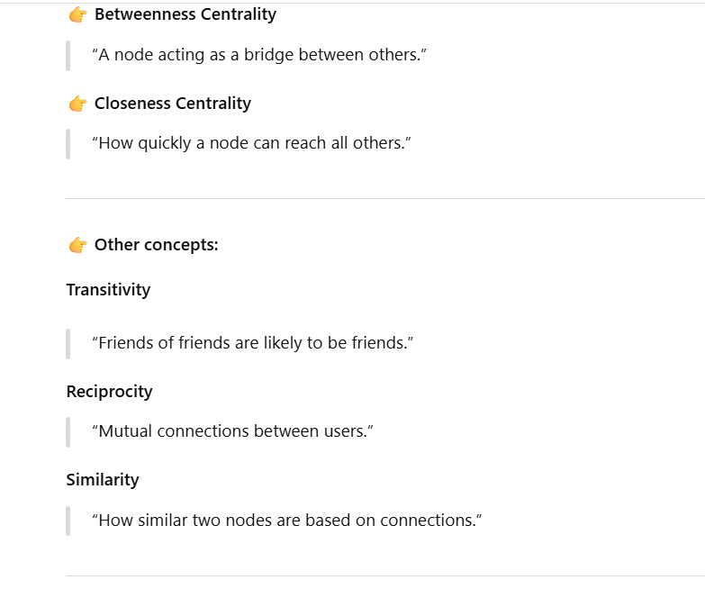

Information diffusion is the process by which information spreads from one entity to another across a network, such as people in a social network, websites on the internet, or devices in a communication system. In data science and network analysis, it explains how ideas, news, rumors, or content propagate over time through connections between nodes

